News Article Classification — ML Pipeline
Project Overview:
This project implements a script-based machine learning pipeline to classify news articles into major categories using NLP techniques. The system performs text preprocessing, TF-IDF feature extraction, and Linear SVM training with hyper parameter tuning. The full work flow runs from the terminal through modular Python scripts.

Objective:
Build a reproducible ML pipeline that classifies news articles into categories such as: Sports Business Technology Politics Entertainment The implementation follows strict script-only architecture without Jupyter notebooks.

Dataset Source:
Dataset: BBC News style labeled dataset ( from kaggle)
File used: BBCNews.csv
Format: CSV
Text column: descr
Label column: tags
First tag is extracted as the primary class label
Rare classes are filtered to avoid class sparsity and split errors
During preprocessing: first tag is extracted as class label rare labels removed only core news categories retained

Model Choice:
Linear Support Vector Machine (Linear SVM)
Suitable for high-dimensional sparse text features
Works effectively with TF-IDF vectors
Uses class balancing
Hyper parameter tuning performed using Grid Search cross-validation
Feature Engineering
TF-IDF vectorization with: n-grams (1–3) max feature cap rare term filtering common term filtering sub-linear term frequency scaling This improves semantic signal and margin separation.

Evaluation Metrics
Accuracy recall precision Confusion Matrix classification report Metrics saved to file Confusion matrix plot generated

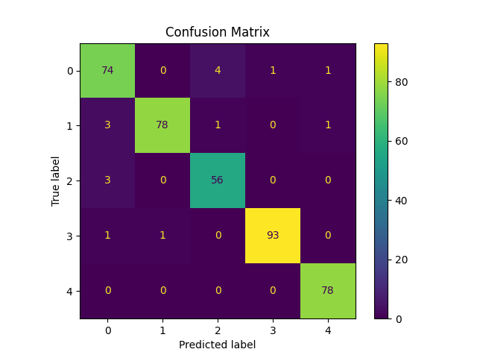
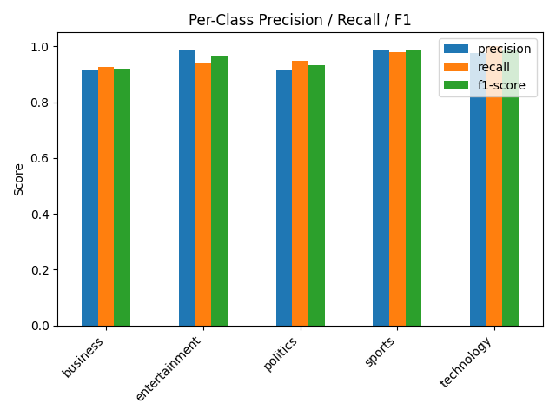

Final Result
Text cleaned and normalized
TF-IDF n-gram features generated
Linear SVM trained with tuned C parameter
Metrics saved in results/metrics.txt for review

Classification Report:

 | precision | recall | f1-score | support
business | 0.91 | 0.93 | 0.92 | 80
entertainment | 0.99 | 0.94 | 0.96 | 83
politics | 0.92 | 0.95 | 0.93 | 59
sports | 0.99 | 0.98 | 0.98 | 95
technology | 0.97 | 1.00 | 0.99 | 78
accuracy | 0.96 | 395
macro | avg | 0.96 | 0.96 | 0.96 | 395
weighted | avg | 0.96 | 0.96 | 0.96 | 395
Project | Structure

Project Structure

news_classification_project/
│
├── data/
│ ├── raw/
│ └── processed/
│
├── src/
│ ├── __init__.py
│ ├── config.py
│ ├── data_preprocessing.py
│ ├── feature_engineering.py
│ ├── train.py
│ ├── evaluate.py
│
├── models/
│
├── results/
│ └── metrics.txt
│
├── requirements.txt
├── README.md
└── main.py

How To Run (Terminal Only)

1.Create Virtual Environment:

python -m venv venv
venv\Scripts\activate

2.Install Dependencies:
pip install -r requirements.txt

3.Run Full Pipeline:
python main.py

Key Design Decisions
Script-only architecture (assignment compliant) Modular pipeline design Config-driven paths Reproducible splits Tuned linear SVM baseline Feature-rich TF-IDF setup Label noise reduction Controlled class filtering

Limitations:
Uses classical ML (no deep learning embeddings)
Label derived from first tag only
No semantic embeddings (by assignment constraint)

